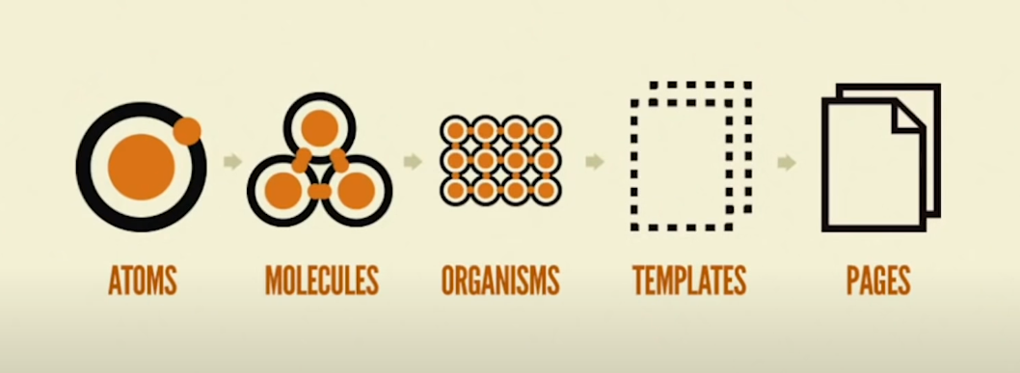

Atomic design is a methodology for creating modular and scalable design systems that involves breaking down a user interface into smaller, reusable components called "atoms," "molecules," "organisms," "templates," and "pages."

* Atoms are the smallest and most basic building blocks of a user interface, such as buttons, inputs, and labels. Atoms cannot be broken down into smaller parts and should be designed to be used in different contexts and situations.
* Molecules are groups of atoms that work together to form more complex UI elements, such as forms, cards, and navigation menus.
* Organisms are groups of molecules that work together to form distinct sections of a UI, such as headers, footers, and product listings.
* Templates are higher-level layouts that define the overall structure and composition of a page or screen, such as a home page, a product detail page, or a login page.
* Pages are the final output of a design system, representing specific instances of a template with real content and data.

Neither Bootstrap nor Material UI explicitly use the atomic design principle, they both incorporate some of its core concepts and principles into their design systems, such as modularity, reusability, and consistency.

**Reference** <https://www.youtube.com/watch?v=W3A33dmp17E>